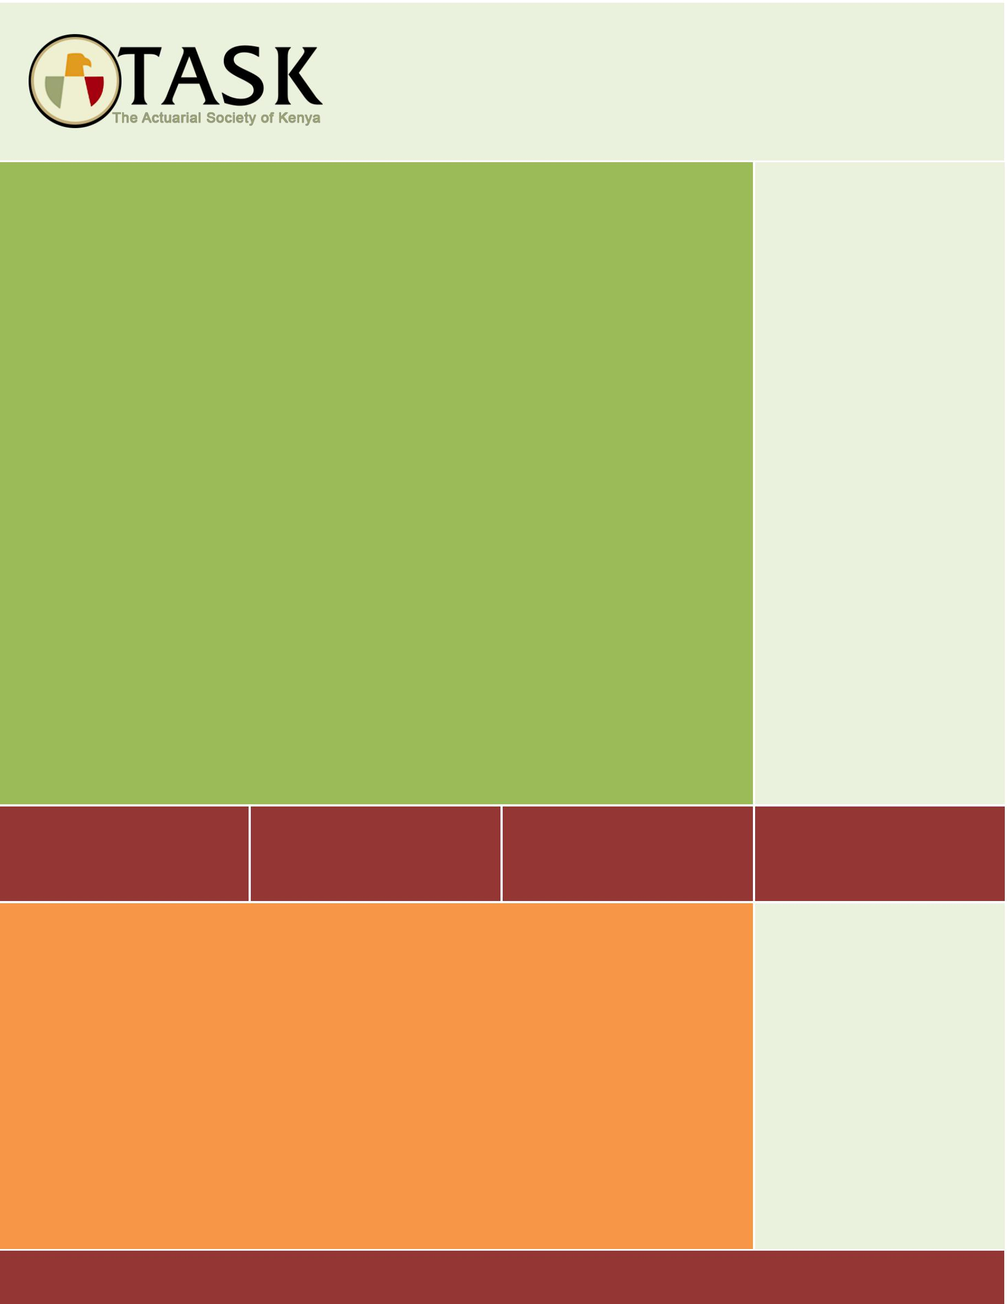

An Analysis of AKI Industry Data

Prepared by: The Life Insurance Working Party of TASK

May 2021

BACKGROUND

The Association of Kenya Insurers (AKI) collects data from local insurers with the purpose of understanding the trends in the insurance industry. The latest set of data was collected from life insurers and covered the period from 2012 to 2017. AKI has provided this data to TASK for assessment in order to understand the consumption of life insurance products.

The data covered the following life insurance product lines:
- Individual Life
- Group Life
- Credit Life
- Annuity

TASK, through its Life Working Party has analysed the data and provide a summary in this report.

DATA

In the course of cleaning and analysing the data supplied by AKI, TASK encountered several challenges and issues that may impact the outcome of the analysis. These are highlighted below:

- Numerous missing data/information – such entries had to be deleted resulting in loss of key information.
- Inconsistency in labelling and collection of key parameters – for example, labelling of key products may differ from company to company, hence not possible to know what product lines these relate to.
- Some companies would collect data for a period of time but miss data for certain years. Hence not possible to appreciate the trends in the industry.
- Mixing of information – some companies would combine
- Repeated/duplicate data entries

The analysis aimed to understand the trends in life insurance, including the growth in premiums, sums assured, growth in number of policyholders (or members for group schemes), age of insurers, claims experience etc. Such detailed analysis was however not possible due to the challenges described above.

Further, the data is only collected for the period up to 2017. A lot has happened in the insurance sector since 2017 (for example, emphasis on digitalisation) and therefore some of the trends, or findings, may likely have been overtaken by events. Important for this analysis to be conducted once more when up to date data is made available.

Users of this report are therefore encouraged to take good note of the above matters as they read this report.

Due to the large size of the data set, TASK analysts used Python to collate, prepare and analyse the data.

INDIVIDUAL LIFE

Product preference

The analysis sought to know which products are popular with consumers of individual life insurance. The graph below gives a highlight based on number of policyholders under each product line:

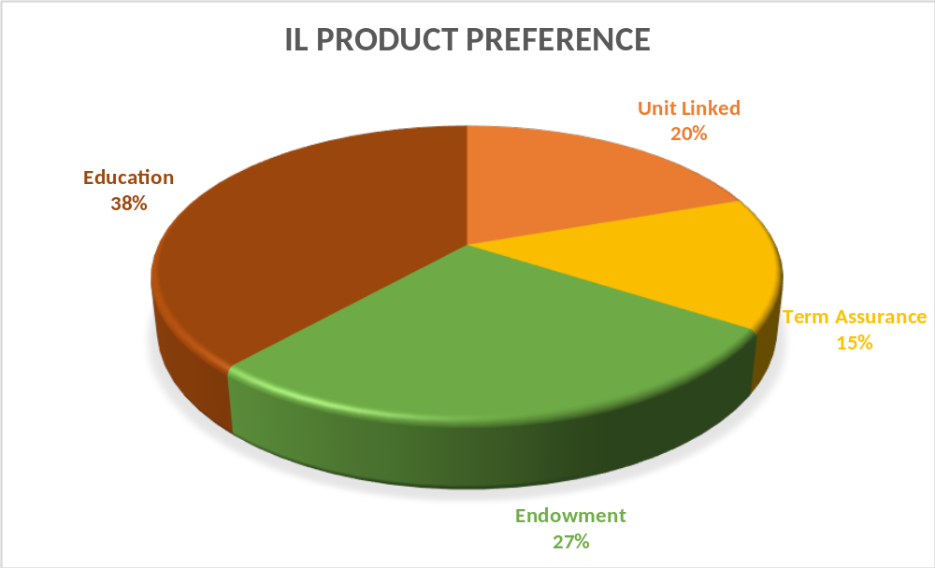

Education products appear to be most popular, at 38%. Although Education and Endowment products are shown as separate products, it is usual for most education products to be endowment in nature. Therefore, it is not incorrect to conclude that Endowment products, which combine elements of risk and savings are more preferred by consumers of life insurance.

Pure risk products have not been easy to sell in the Kenya market, but a 15% take up rate for Term Assurance appear higher than one would expect.

There was no direct reference to Funeral plans in the data, which made it impossible to assess the take of this product. (Eric: Kindly confirm., That’s correct) There has been an increased interest in this product line so it would have been necessary to consider how well it is performing. A future data collection exercise should ensure that a clear reference to such product is made.

Average premiums

The graph below shows how the average premium has grown over the period of study.

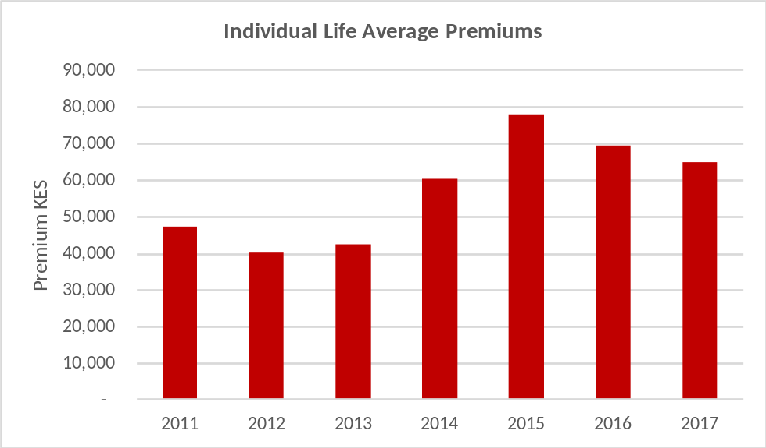

The gradual growth of average premiums for the period up to 2015 was expected considering the influence of inflation. The decline thereafter should be a cause for concern – this could be as a result of reduced appetite for life insurance products, hence policyholders targeting the minimum premiums allowable.

Age of policyholders

The chart below highlights the age groups of takers of life insurance policies.

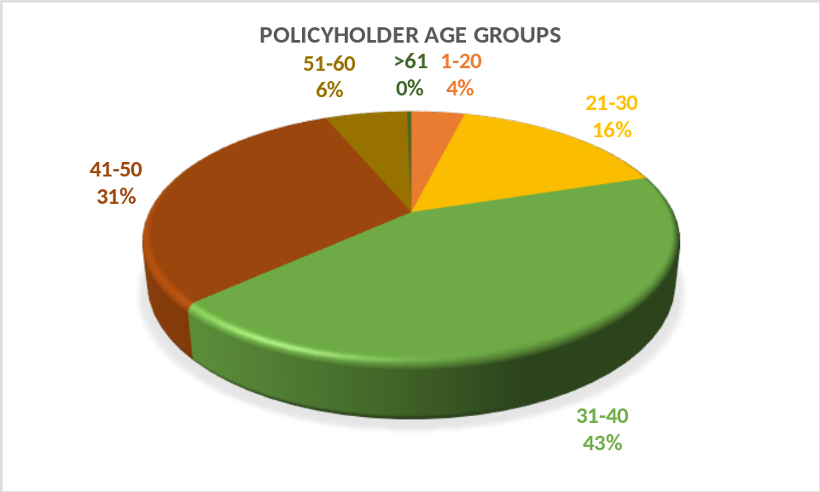

Age groups of between 30-50yrs account for almost 75% of life insurance uptake. Insurers have to initiate focus for the larger population aged below 30yrs by developing products, or operational systems, that are attractive to them. This age group is the likely area of potential growth for insurers.

GROUP and CREDIT LIFE

The GL data produced results that required further investigation of the data supplied. Some outcomes were not in line with what one would expect of such a product line – this would include the growth of premiums over years, claims experience etc which bore results that are questionable. TASK has therefore only selected results where sensible data was available.

Age of members

Chart below highlights the age group of GL and CL schemes:

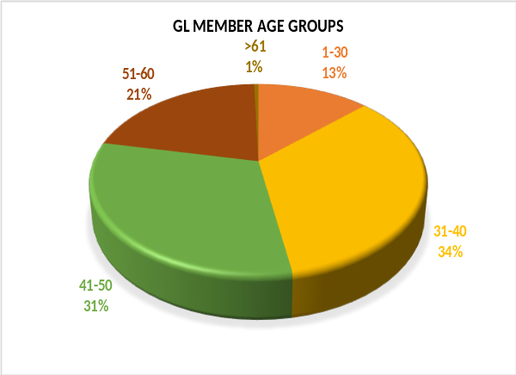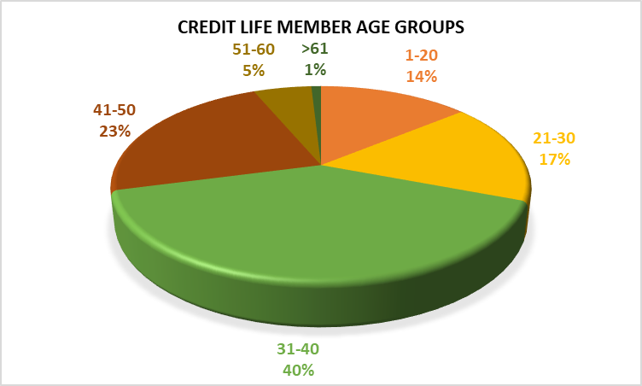

The average age of the Kenya work force lies between 30-50, and this is supported by the graph above for GL. So it is not surprising that pricing of GL schemes where data is not available would be based on age 40yrs. However, the trend is now heading towards a younger work force (below 30yrs) and this is likely to reflect in the latest data covering year 2020.

The CL data show a similar picture of age groups with higher loan take up, i.e. between 30-50yrs.

Sum assured bands

The graph below shows the SA bands for the GL schemes.

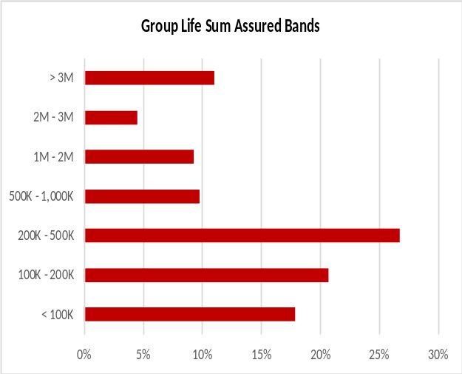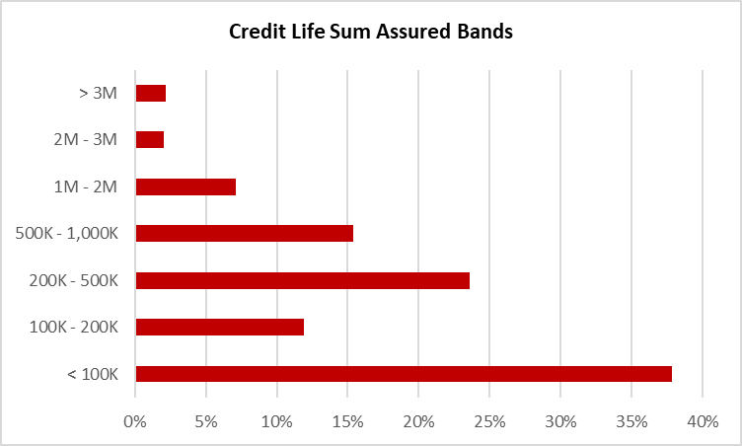

For GL, a majority of the members, at 27% have sums assured of between KES 200,000 to KES 500,000, and that 75% of members have cover of KES 1m or less. The number of members with cover of at least KES 3m are 11% of the total. This is questionable and is likely to be as a result of quality of data that needs to be checked.

For CL, most loans taken are of amount KES 100,000 or lower and that 90% of loans are of amount of KES 1m or less.

Delays in claims reporting and settlement

The delays in claim reporting are an important feature of GL schemes assessment, in particular in relation to understanding of reserves for incurred but not reported.

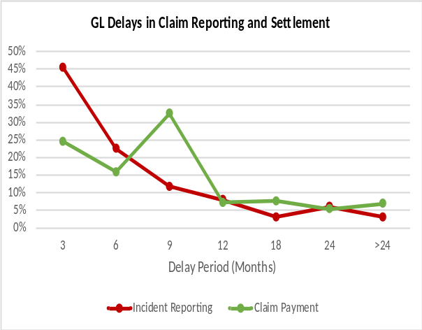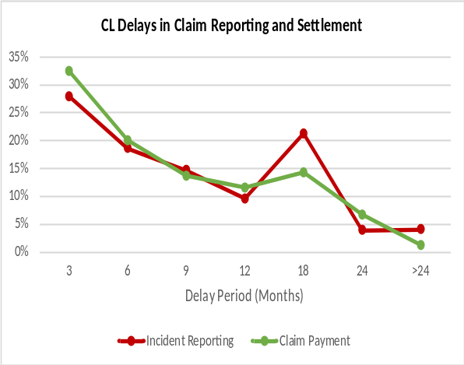

It is inferred from the GL graph that it takes 3 months for 45% of the claims to be reported to the insurer and that less than 3% get reported after 2yrs of incidence.

25% of reported GL claims to be paid within 3 months. This is a surprising result in that insurers promise to pay claims within a month of reporting. The result of 32% claim settlement in 9 months is not normal and may require some further check on the data.

The CL results show an incident reporting rate of only 28% within 3 months which is worse than that of GL. However, the rate is higher than for GL for settlement within 3 moths of reporting.

ANNUITIES

TASK had planned to carry out a more detailed analysis of the annuities, to include a rough guide of the longevity experience of the existing book. However, there were serious limitations on the data provided that would easily put to question the credibility of the results. This exercise will therefore not be conducted but in the conclusion section of this paper TASK has provided some guide on collection of quality data for actuarial use in the future. In the meantime, TASK would refer readers of this paper to the analysis conducted in 2020 on the Income Drawdown product paper “TASK Life WP_Analsys of the IDD Pension Product” section 3 which was based on alternative research and dataset.

Age group

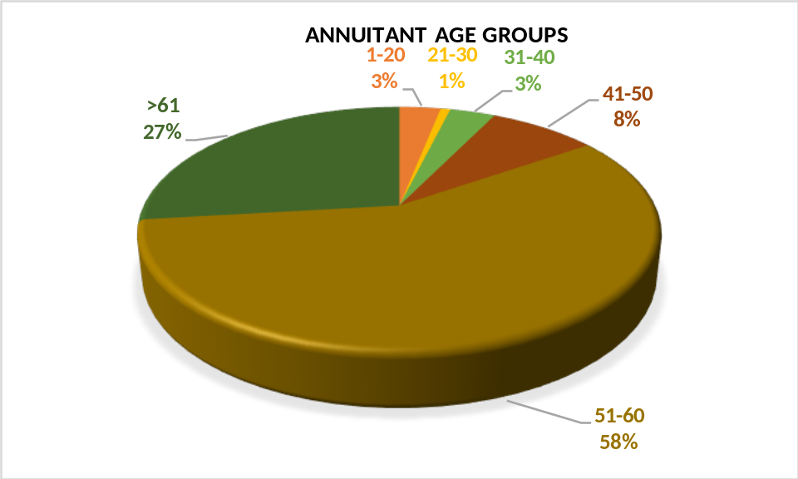

(Eric: Please confirm what the ages below 50 yrs represent, likely to be dependants. See if this is description is included in the data.)
The data does not make a reference to dependants. It could be an issue of data quality. The category may need to be included in future.

75% of the annuitants are aged above 50yrs. There is likelihood of the data including dependants and early retirees who cover the 25% aged at 50yrs or below.

Annuity premium
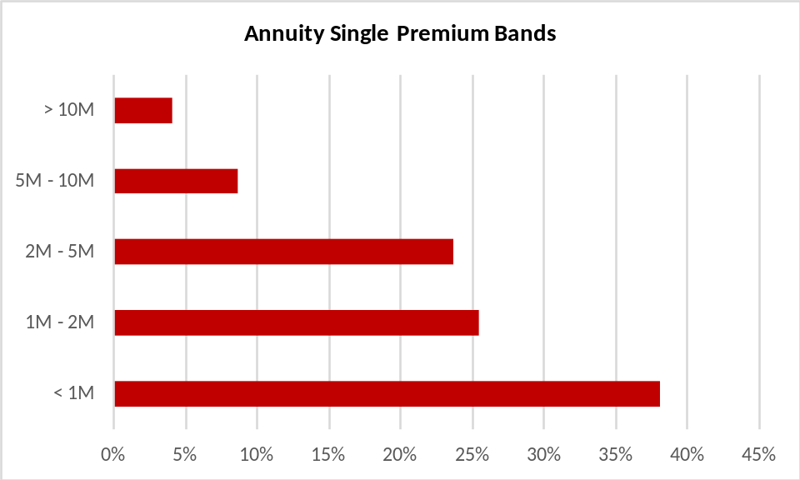

Almost 40% of annuitants purchase annuity with premium of less than KES 1m, which currently is likely to be the Trivial Pension amount as per RBA rules. This brings to question the habit of savings for pension by the Kenyan public.

Conclusion

The quality of data matters significantly on the kind of inferences one can draw and how reliable and credible the results are. TASK would strongly emphasise that considerable time be spent to source quality data. The advantage is that members of TASK handle most of the requisite data in their respective companies and that TASK will be at hand support AKI in the next round of data collection to ensure quality analysis are derived from the data.

